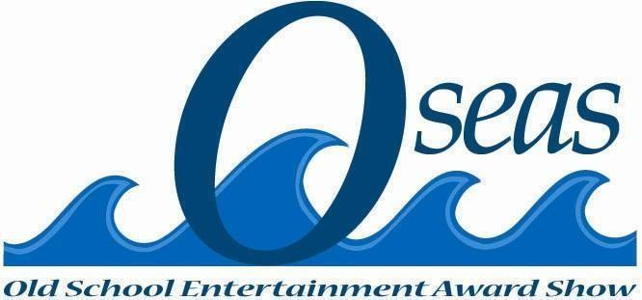

Take Back Our Neighborhood Benefit Concert Tour 2023

Vision
Our vision is to be a resource to youth facing options detrimental to their future.
Our benefit concert tours will provide opportunities and alternatives to violence
in the streets.
Our members will serve as role models engaging youth to pull them out
of circumstances risking their future.

Mission Statement
Take Back Our Neighborhood Benefit Concert Tour 2023: Ignite various members of the
community to join a movement to provide youth plagued by violence with
viable options for a hopeful future.

- Endorsements-

The Honorable Dr. Johnny Ford
President of The World Conference of Mayors and the
Historic Black Towns and Settlements Alliance-Tuskegee, AL
Commissioner Samuel B. Ings
Vice President of Trust for the World Conference of
Mayors and the Historic Black Towns and Settlements Alliance.
Former Commissioner, District 6, City of Orlando, FL
Ambassador Dr. E. Faye Williams, Esq.
Her Excellency, H.E. United Nations Peace Ambassador
President/CEO Emeritus, National Congress of Black Women, Inc.
International President, The Dick Gregory Society, Inc., DC

Mr. Robert “Bobby” Hunter
Former Harlem Globetrotter, Humanitarian/Ambassador

The Honorable Judge Jerrauld C. Jones
District Circuit Court Chief Judge, Norfolk, VA

Frequently Asked Questions

WHY ARE WE TAKING BACK OUR NEIGHBORHOODS?

The late Marvin Gaye and his wife Anna Gordy-Gaye gave a directive to Cecil Jenkins to
“Save the Children. Save the Babies.” This mandate stayed with Cecil. It took flight in 2016 when three of his nephews and their friend were gunned down while walking to a local convenience store in the Berkley neighborhood of Norfolk, VA. The directive from Marvin Gaye and his wife, Anna Gordy-Gaye, was further heightened in Cecil’s life by the shooting death of his cousin, Sierra Jenkins, a twenty five-year old former CNN journalist, and a reporter for Sierra, who had just celebrated a birthday, would have reported the story of the March 19, 2022 shooting, instead, she became The Story. Five individuals were shot that night. Sierra and two others died as a result of those shootings.
Cecil’s initiative to Take Back Our Neighborhood(s) is his focal point. However, the directive given by Marvin Gaye and Anna Gordy-Gaye is extended to all citizens throughout America. Norfolk, VA will serve as the pilot project for the movement. This initiative has drawn the attention and participation of leaders throughout the country who share the same drive of annihilating violence from the lives of our children. Our Planning Committee has invoked the assistance of the FBI, local law enforcement agencies, businesses, athletes, famous performing artists, schools, churches and community grassroots organizations to join us in focusing on the eradication of gun violence in cities across America. Cecil has The Solution to the aforementioned problems. He will unveil it very soon.
Relevant News Articles

- Virginia Pilot reporter Sierra Jenkins dead after shooting outside Norfolk bar (nypost.com)

- Berkeley police search for gunman who shot, injured 3 teens - ABC7 San Francisco (abc7news.com)
WHO ARE WE?

We are a team of sixty-five like-minded community leaders who have been exposed to the very same gang and gun violence that plague our youth.

WHEN IS THE FIRST CONCERT?

May 6, 2023 Norfolk, VA (A twenty-city tour is the targeted one-year goal)
Norfolk Scope Arena

STATISTICS

More Americans died of gun-related injuries in 2020 than in any other year on record, according to recently published statistics from the Centers for Disease Control and Prevention (CDC). The statistic includes a record number of gun related murders, as well as near-record numbers of firearm suicides. Sadly, local and national news reports now remain weighed down with daily reports of gun violence activities throughout the United States of America.

GOAL

We promise to bring awareness and direct resources of sustenance to each youth and transitional peoples (ages 18-24) group in each city of our nation through a coalition of Mayors.

The good news is that our improved understanding of human behavior and mental health matters helps us see that preventing gun violence isn't about dealing solely with bad people. It's about encouraging productive behavior among our youth, while increasing their focus on their future and developing their genuine respect for the lives of others. Ultimately, our goal is to facilitate opportunities for youth to engage in functional roles in society.

Our “Wall of Remembrance”: Children who have been lost to gun violence in any way.

Our “Living Legacy List”: Children who commit to a safe lifestyle by living with no bullying, no gangs and no drugs.

PLAN & DIRECTIVE

- We will hold benefit concert tours in various cities inviting youth in the communities and provide an assortment of direct resources during the concert via breakout rooms/areas: job fairs, healthy food, housing, clothing, self-confidence coaching, select skill building activities, safe schools initiatives, financial literacy, voting awareness, domestic and sexual violence services, and mental health awareness/assistance. While we will use concerts as a means of drawing the masses and encouraging them to stand against gun violence, we are not in the concert business. The concert is only one component among several components of the project that is designed to unite and inform as many people as possible.

- Our Community Planning Committee acknowledges that mental health services and behavioral modification are consistent needs throughout communities in America. We will address this urgent need through connecting with the myriad mental health professionals that have joined our committee. We will adhere to their guidance in planning and implementing a mental health plan as an area of primary focus.

Sponsors Are Needed!

CONTACT INFORMATION

Dr. Sesil T. Jenkins 757-469-9183

Email Address: benefitconcerttour2023@gmail.com

Mailing Address:
Benefit Concert Tour
P.O. Box 36316
Las Vegas, NV 89133-6316

Website: benefitconcerttour.com (under construction-launching soon)

MAKE A DONATION: Zelle benefitconcerttour2023@gmail.com

Revised: Foxye Brown-Jackson 12/1/2022
Dr. Soyini Richards

